**Appendix 1**

**Transforming Dance**

|  |  |
| --- | --- |
| Open Geometer’s Sketchpad.  Using the *circle tool* and *straightedge tool* , draw a stick man: |  |

**Translation**

1. Highlight the stick man with the *select tool*  by either clicking on each part or clicking outside and dragging the cursor over him. Choose *Translate* from the *Transform* menu. Select *Rectangular Vector* in the dialogue box and enter a horizontal and vertical distance (the **vector**) to move the stick man.

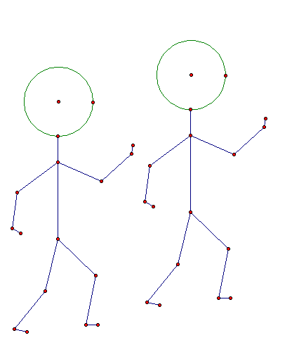

1. Select and drag the point to wiggle the hips of the original stick man. How does the image move?
2. Create a group of dancers by translating the image figure again and again. Have some fun with your dancers!

**Reflection**

1. In the *File* menu, open a *new sketch* and a draw a new stick man. Use the *straightedge tool* , to draw a **mirror line***.* Either double click on the mirror line or select it and use the *Transform* menu and choose *mark mirror*. Now select the stick man and choose *Reflect* from the *Transform* menu.

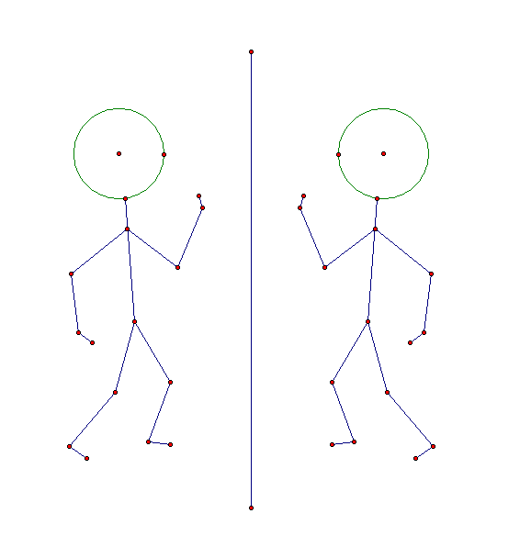

1. Select and drag parts of the original stick man. How does the reflected image move?
2. Select and drag the mirror line. What happens to the dancers?
3. Select and drag one end the mirror line to change its orientation. What happens to the image figure?
4. Draw another mirror line parallel to the first and to the right of your reflected stick man. Reflect your reflected image in this mirror line. What do you notice about the relation of the last image to your original stick figure?

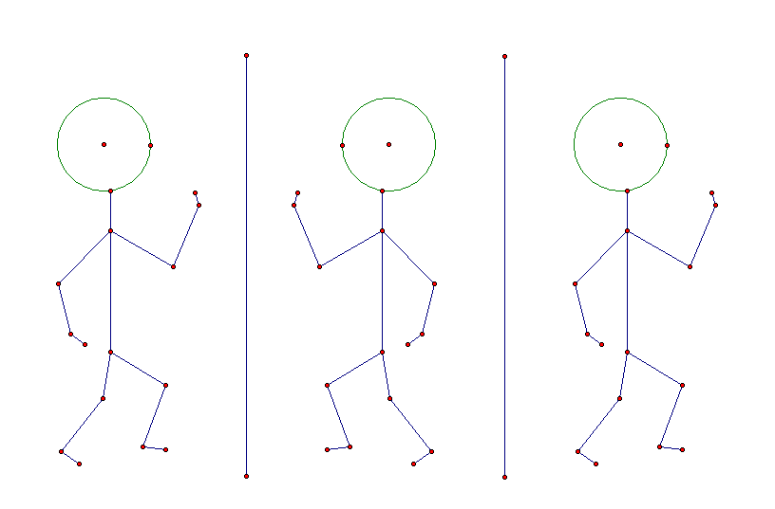

1. Try drawing a translation vector that would *translate* your original figure onto this third figure.

**Rotation**

1. In the *File* menu, open a *new sketch* and a draw a new stick man. Use the *point tool* , to draw a **centre of rotation.** Double click on the point to mark it as the centre of rotation. Select the stick man and choose *Rotate* from the *Transform* menu. Enter an angle of rotation, e.g.

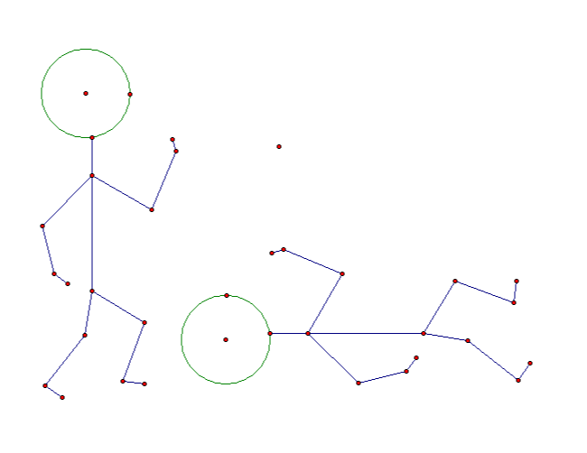

Which way did your stick man rotate (clockwise or anticlockwise)?

1. Return to your sketch with the double reflection. Move the second mirror line so that it is no longer parallel to the first mirror line. How does the third stick man relate to the first man? Try and find a centre of rotation and an angle that will rotate your original stick man onto the third man.

**Appendix 2**

**Exploring Enlargement and Similar Triangles with GSP - Pilot**

**Activity 1 - Exploring enlarging a triangle from a given centre**

* Open the Geometer’s Sketchpad file ‘Exploring Enlargement and Similar Triangles’.
* Using the *select tool*, double click the point to the left of ΔABC (the yellow triangle). This is now the centre of enlargement.
* Now highlight the ‘scale factor’ at the bottom of the screen and in the *Transform* menu, select *Mark Scale Factor*.
* Highlight the whole triangle by selecting all the vertices, edges and interior. In the *Transform* menu, select *Dilate*. The dialogue box should say *Dilate by Marked Ratio* (i.e. enlarge by the number on the scale factor slider) and click *Dilate*.
* Label the vertices of the new triangle by highlighting them and in the *Display* menu, select *Show Labels*. The image produced should be labelled ΔA’B’C’.

1. To move the vertices of the original triangle, click on a vertex and drag it around the screen. Investigate what happens and write down what you notice.
2. Investigate what happens when you move the centre of enlargement closer to the original triangle or further away. What if the centre of enlargement is inside the original triangle? What if the centre of enlargement was on one of the vertices of the original triangle?

How does the position of the centre of enlargement affect the image produced?

1. Drag point Y on the scale factor slider to change the scale factor to 3, 4, 5 etc. Now change the scale factor to 0.5. How does changing the scale factor affect the image produced?

ΔABC and ΔA’B’C’ are said to be **similar triangles.**

**Activity 2 – Exploring corresponding angles in similar triangles**

* Return the scale factor to 2 by moving the slider.
* To measure click on A, then B then C and in the *Measure* menu, select *Angle* (this measures the interior angle at vertex B). Measure  in the same way.
* Repeat for and, and forand.

1. Drag the vertices of the original triangle to change its size and shape. What do you notice about the angle measures of the two triangles?
2. Change the scale factor using the slider. What do you notice about the angles?
3. **Challenge** – Can you explain why?

**Activity 3 – Exploring corresponding sides in similar triangles**

* To measure line AB by select the line and in the *Measure* menu, select *Length*. Now measure line A’B’ and compare the two lengths.
* Repeat for sides BC and B’C’, and for CA and C’A’ and compare the lengths.
* To calculate the ratio of the lengths of the sides , select *Calculate* from the *Measure* menu, then click on the line A’B’, followed by ÷, then click on the line AB, then click *OK*.
* Compare the ratios of the other two pairs of corresponding sides in the same way.

1. Drag the vertices of the original triangle to change its size and shape. What do you notice about the ratios of corresponding sides?
2. Change the scale factor using the slider. What do you notice about the three ratios?
3. **Challenge** - Can you explain why?

**SAVE YOUR WORK BEFORE MOVING ON TO THE EXTENSION ACTIVITY!**

**Extension**

**Activity 4 – Exploring areas of similar triangles**

* Open the Geometer’s Sketchpad file ‘Exploring Enlargement and Similar Triangles’.
* Enlarge the triangle by scale factor 2 (as in Activity 1) and label the vertices of the image.
* Calculate the **ratio of lengths** and compare it to the scale factor.
* To calculate the area of ΔABC, highlight the yellow interior and in the *Measure* menu, select *Area*. Calculate the area of ΔA’B’C’ in the same way.
* To calculate the **ratio of the two areas**, select calculate from the *Measure* menu, then click on the calculated area of ΔA’B’C’, followed by ÷, then click on the calculated area of ΔABC, then click *OK*.
* To put the length and area ratios into a table, select the ratios and and select *Tabulate* from the *Graph* menu. Double click in the table to keep this calculation and then use the slider at the bottom of the screen and drag Y to change the scale factor to 3. Double-click on the table again to add the calculations to the table. Repeat for other scale factors.

1. Are the area ratios what you expected? Why?
2. What is the relationship between the scale factor (ratio of sides) and the area ratios?
3. **Challenge** - Can you explain why?

**Appendix 3**

**Exploring Enlargement and Similar Triangles with GSP**

**Activity 1 - Exploring enlarging a triangle from a given centre**

* Open the Geometer’s Sketchpad file ‘Exploring Enlargement and Similar Triangles’.
* Using the *select tool*, double click the point to the left of ΔABC (the yellow triangle). This is now the centre of enlargement.
* Now highlight the ‘scale factor’ at the bottom of the screen and in the *Transform* menu, select *Mark Scale Factor*.
* Highlight the whole triangle by selecting all the vertices, edges and interior. In the *Transform* menu, select *Dilate*. The dialogue box should say *Dilate by Marked Ratio* (i.e. enlarge by the number on the scale factor slider) and click *Dilate*.
* Label the vertices of the new triangle by highlighting them and in the *Display* menu, select *Show Labels*. The image produced should be labelled ΔA’B’C’.

1. To move the vertices of the original triangle, click on a vertex and drag it around the screen. Investigate what happens and write down what you notice.
2. Investigate what happens when you move the centre of enlargement closer to the original triangle or further away. What if the centre of enlargement is inside the original triangle? What if the centre of enlargement was on one of the vertices of the original triangle?

How does the position of the centre of enlargement affect the image produced?

1. Drag point Y on the scale factor slider to change the scale factor to 3, 4, 5 etc. Now change the scale factor to 0.5. How does changing the scale factor affect the image produced?
2. **Challenge** – Can you explain why?

ΔABC and ΔA’B’C’ are said to be **similar triangles.**

**Activity 2 – Exploring corresponding angles in similar triangles**

* Return the scale factor to 2 by moving the slider.
* To measure click on A, then B then C and in the *Measure* menu, select *Angle* (this measures the interior angle at vertex B).
* Measure  in the same way.
* Repeat for and, and forand.

1. Drag the vertices of the original triangle to change its size and shape. What do you notice about the angle measures of the two triangles?
2. Change the scale factor using the slider. What do you notice about the angles?
3. **Challenge** – Can you explain why?

**Activity 3 – Exploring corresponding sides in similar triangles**

* To measure line AB by select the line and in the *Measure* menu, select *Length*. Now measure line A’B’ and compare the two lengths.
* Repeat for sides BC and B’C’, and for CA and C’A’ and compare the lengths.
* To calculate the ratio of the lengths of the sides , select *Calculate* from the *Measure* menu, then click on the line A’B’, followed by ÷, then click on the line AB, then click *OK*.
* Compare the ratios of the other two pairs of corresponding sides in the same way.

1. Drag the vertices of the original triangle to change its size and shape. What do you notice about the ratios of corresponding sides?
2. Change the scale factor using the slider. What do you notice about the three ratios?
3. **Challenge** - Can you explain why?

**SAVE YOUR WORK BEFORE MOVING ON TO THE EXTENSION ACTIVITY!**

**Extension**

**Activity 4 – Exploring areas of similar triangles**

* Open the Geometer’s Sketchpad file ‘Exploring Enlargement and Similar Triangles’.
* Enlarge the triangle by scale factor 2 (as in Activity 1) and label the vertices of the image.
* Calculate the **ratio of lengths** and compare it to the scale factor.
* To calculate the area of ΔABC, highlight the yellow interior and in the *Measure* menu, select *Area*. Calculate the area of ΔA’B’C’ in the same way.
* To calculate the **ratio of the two areas**, select calculate from the *Measure* menu, then click on the calculated area of ΔA’B’C’, followed by ÷, then click on the calculated area of ΔABC, then click *OK*.

1. Is the area ratio as you expected? Why?

* To put the length and area ratios into a table, select the ratios and and select *Tabulate* from the *Graph* menu. Double click in the table to keep this calculation.
* Use the slider to change the scale factor to 3. Double-click on the table again to add the calculations to the table.
* Repeat for other scale factors.

1. What is the relationship between the scale factor (ratio of sides) and the area ratios?
2. **Challenge** - Can you explain why?

**Appendix 4**

**Using Geometer’s Sketchpad - Student Feedback Sheet**

1. How did you find using Geometer’s Sketchpad (GSP)?
2. You have previously learnt how to enlarge from a given scale factor using pencil and paper. Have you learnt anything about enlargement using GSP that you did not previously know/understand?
3. How did using GSP help you to understand the effect of the centre of enlargement when enlarging a shape?
4. How did using GSP help you to understand the effect of the scale factor when enlarging a shape?
5. How did using GSP help you to understand the properties of similar triangles? (i.e. angles properties, ratio of sides, ratio of areas)