


Key Information
This workbook belongs to:

_________________________________
Antibiotic

Awareness
- Antibiotics are used to treat bacterial infections and DO NOT work against infection caused by viruses (e.g. Cold and Flu)
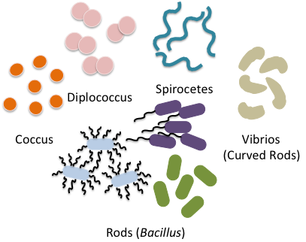
- Bacteria can become resistant to antibiotics meaning infections can no longer be treated using antibiotics

- Antibiotic resistance is one of the biggest global health threats today and is occurring as a result of 6 factors:
- Over-prescribing of antibiotics by health workers
Bacteria come in different shapes
- Patients not finishing their full treatment course of antibiotics
- Over-use of antibiotics in farming
- Poor infection control in hospitals and clinics
- Lack of hygiene and poor sanitation
- Lack of new antibiotics being developed


If we do not act now to slow antibiotic resistance there will be devastating consequences. Many infections such as tuberculosis and pneumonia will be untreatable and medical practices such as cancer treatments and minor surgeries will be very high risk due to resistant bacterial infections.

- You can help by:
- - Never pressuring health care providers for antibiotics
- - Taking antibiotics as directed and completing the course even if your symptoms have disappeared
- Never keeping antibiotics for future use
- Never sharing antibiotics with anyone else
- Minimising the risk of infection with good hygiene
- Sharing this information with your friends and family to help protect antibiotics and your future
Bacteria vs Viruses Colouring

Bacteria
Bacteria are single cells that can be free-living
There are lots of shapes and sizes of bacteria
Bacteria have a cell wall
Vaccines can prevent some bacterial infections
Bacterial Infections can be treated with Antibiotics
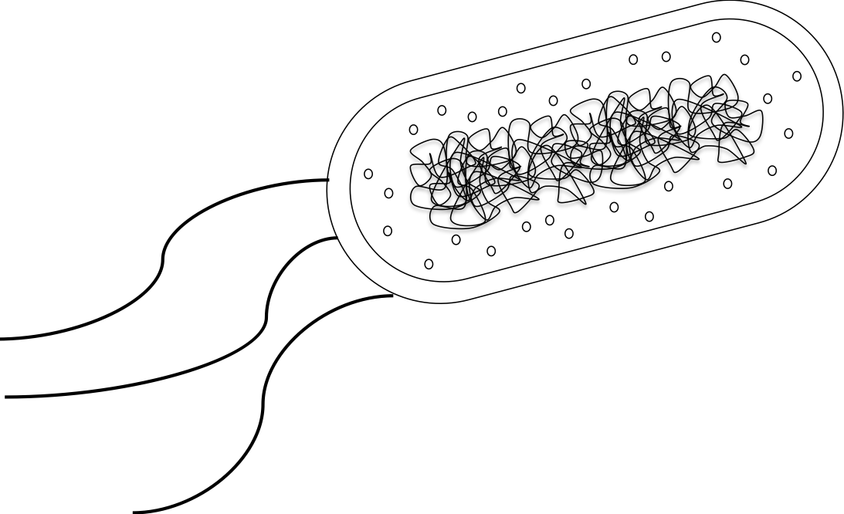
Cytoplasm
Bacterial DNA
Bacterial Cell Wall
Bacterial Flagella
(for ‘swimming’ and movement)

Viruses
Viruses live inside host cell and require their machinery
Viruses are much smaller than bacteria
Some viruses can infect bacterial cells making them ill
Vaccines can prevent some viral infections
Viral Infections cannot be treated with antibiotics
Viral genome
Protein coat
Match the statements to the microbe

Cause tuberculosis
Cause colds and flu
Can live inside or outside your cells
The smallest kind of microbe
Always live inside your cells
Cannot be treated with antibiotics
Can be treated with antibiotics

Viruses
Bacteria

Have a cell wall
Down the microscope
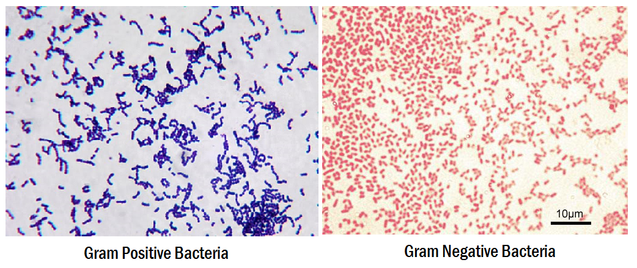

Source: http://laboratoryinfo.com/gram-staining-principle-procedure-interpretation-and-animation/

Scientists use Gram staining to identify bacteria based on the structure of the cell wall.

Gram Positive Bacteria will stain PURPLE and Gram Negative Bacteria will stain RED. The bacteria that stain purple have a thick layer of peptidoglycan in their cell wall. The bacteria that stain red have a thinner layer of peptidoglycan, and an extra cell membrane.
The Structure of the Bacterial Cell Wall
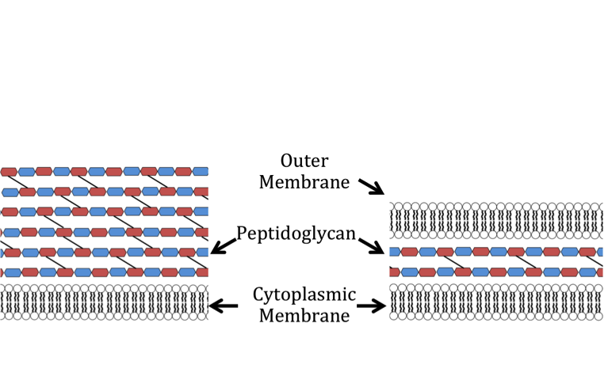
Cytoplasm
Cell Wall
Cell Wall
Gram Negative Bacteria
Gram Positive Bacteria
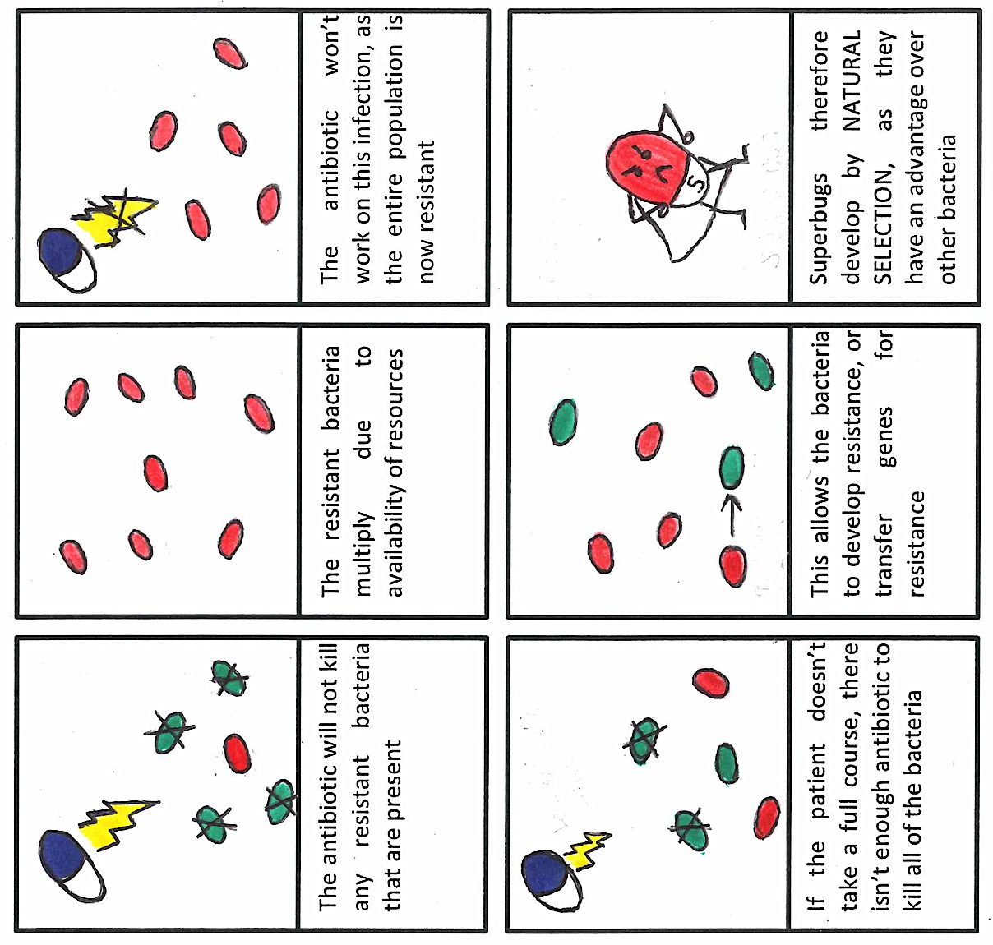
How resistance develops
The antibiotic will not kill any resistant bacteria that are present

The resistant bacteria multiply due to availability of nutrients

The antibiotic won’t work on this infection, as the entire population is now resistant

Superbugs therefore develop by NATURAL SELECTION, as they have an advantage over other bacteria

SUPERBUG!
Causing untreatable infections!
If the patient doesn’t take a full course, there isn’t enough antibiotic to kill all of the bacteria

Less antibiotic present
This allows the bacteria to develop resistance, or transfer genes for resistance

Resistance gene shared
Some bacteria are naturally resistant to certain antibiotics, but others have evolved resistance. Misuse of antibiotics makes this process faster. Misuse includes not taking a full course of antibiotics; or using them when they aren’t needed - for example when you have flu, or to speed up the growth of farm animals.

Antibiotic Maze

Jane is ill, the doctor has given her some antibiotics called Penicillin. It is really important that she finishes all of the antibiotics in the pack, even if she is feeling much better. Can you find a route through the maze and help Jane to take all of her tablets?

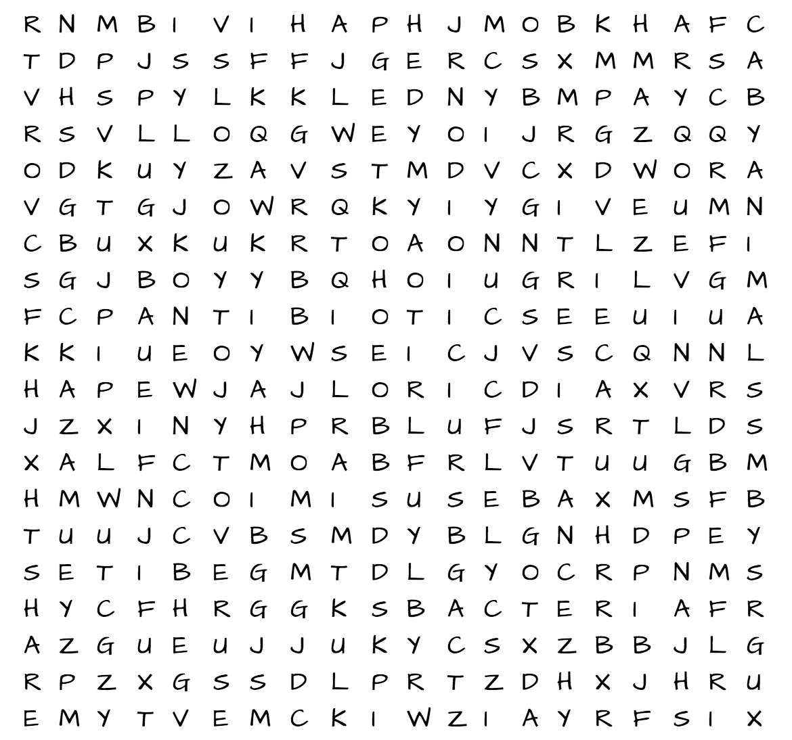
Antibiotic Word Search
- Antibiotics kill infections caused by bacteria
- There are many different types of bacteria
- Antibiotics do not work against viruses so will not cure cold of flu
- Penicillin was the first antibiotic to be discovered in 1928 by a scientist called Alexander Fleming
- Scientists are working hard to find new antibiotics
- Bacteria can gain resistance to antibiotics, this means that the antibiotic can no longer cure the infection

- MRSA is a very nasty bacterium that is resistant to the antibiotic called Methicillin
- Only taking antibiotics when they are prescribed by a doctor will help slow down the development of resistant bacteria
- Completing the entire course of antibiotics will also help prevent bacterial resistance
- NEVER share antibiotics with someone else!
- Antibiotic resistance is caused by overuse and misuse of antibiotics
- Farmers and vets use antibiotics for animals too

Match the bacterium to the disease


Streptococcus pneumoniae
Pseudomonas aeruginosa
Staphylococcus aureus
Escherichia coli
Clostridium difficile
Urinary tract infections

Diarrhoea

Lung disease and ear infections
Lung disease

Skin and wound infections

It is important to know which bug is making you ill, as your doctor can then prescribe you an antibiotic that will work on your infection

How you can help

Unscramble the words in bold to find out how you can help reduce the development and spread of antibiotic resistance

Keep up to date on tnicavcosain ______________

Reduce the sradpe _________ of disease through good nahd-shgwain __________________ technique

Use the full seourc ________ of antibiotics, even if you feel better

Only take ibatiniotcs ______________ that are icpersrbde _____________ by a doctor

Never ask for antibiotics to treat olcd _______ or luf ____ – these diseases are caused by vrsusie _________

Laboratory Notebook

Experiment 1: Microscopy
Use the spaces to sketch (and colour!) what you saw down the microscope
Name, colour and shape

Name, colour and shape

Experiment 2: Single Colony Streaking
Describe what you did, and sketch your
streaking pattern



Experiment 3: Handwashing technique
Colour the areas you missed – do they match up with the most commonly missed areas?

Useful Links
World Health Organisation Fact Sheets and Quizzes on Antibiotic Resistance
http://www.who.int/mediacentre/factsheets/fs194/

Warwick Antimicrobial Interdisciplinary Centre – Find out more about research taking place at the University to tackle Antibiotic resistance
www.warwick.ac.uk/wamic/

