‘Antibiotic Awareness’
Key Stage 3 Workshop:

Guidelines for Organisers

Catherine E Rowland & Anna York
c.e.rowland@warwick.ac.uk
a.york@warwick.ac.uk
Table of Contents
Introduction 3
Structure of the Workshop 3
Introductory talk 3
Activities 7
Questions 8
Plenary Session 8
Feedback 9
Preparation Checklist for the Workshop 10
Materials 11

List of Figures
Figure 1: The feedback system. Jars and tokens are used for students to tell us their favourite activity and rate our explanation of antibiotic resistance. 9

List of Tables
Table 1: The timings of the workshop 3
Table 2: The content of the word game, with discussion points 4
Table 3: Slides from the introductory talk, with discussion points 4
Table 4: The materials required for 'Antibiotic Awareness' 11

Introduction
‘Antibiotic Awareness’ is a one-hour workshop for key stage 3 (KS3) pupils, covering antibiotic resistance, some microbiological techniques, and good hand-washing technique. The workshop is delivered by 5-10 research scientists to a class of 30. A booklet, containing information and puzzles, is used in order to convey key public awareness messages relating to antibiotic resistance. In addition, the workshop has been designed to support the following topics specified in the KS3 curriculum;
- Genetics and evolution: environmental changes and natural selection
- Chromosomes, genes and DNA in heredity
- Structural adaptations of unicellular organisms

Structure of the Workshop
The workshop is designed to be delivered within a one-hour science lesson, and the structure is as given in Table 1;

Table 1: The timings of the workshop
Demonstrator arrival and set up | 1.5hours
Class arrival, name stickers | 5mins
Introductory talk | 10mins
Tasks | 40mins (with 10mins each on 3 stations, plus time for transitions)
Plenary (with questions) | 5mins

Each student should be given a name sticker, with one of three colours. The colours denote at which station that student will begin (stations can be arbitrarily assigned a colour).

Introductory talk

After briefly introducing the team and your aim, the introductory talk begins with a word game – students are asked to raise their hands if they’ve heard of the words, and discussion points can then be raised from these. This game helps demonstrators to gauge the students’ current knowledge and understanding, and thereby tailor the workshop accordingly (students’ understanding may vary considerably between different classes/schools). See Table 2 for the words to be included, along with discussion points.

Table 2: The content of the word game, with discussion points
Word | Discussion points
Germs
Microbe
Bacteria
Virus
Infection
DNA | Can anyone explain what DNA ‘does’?
Superbug
Antibiotic | Has anyone ever been given antibiotics?  Is anyone allergic to antibiotics?
Antibiotic resistance | Can anyone explain what this is?

The learning objectives should then be presented;
- What antibiotic resistance is
- Why it matters
- How antibiotic resistance develops
- How you can help to tackle antibiotic resistance

This is followed by some basic science to form a foundation for the content of the workshop, as shown in Table 3;

Table 3: Slides from the introductory talk, with discussion points
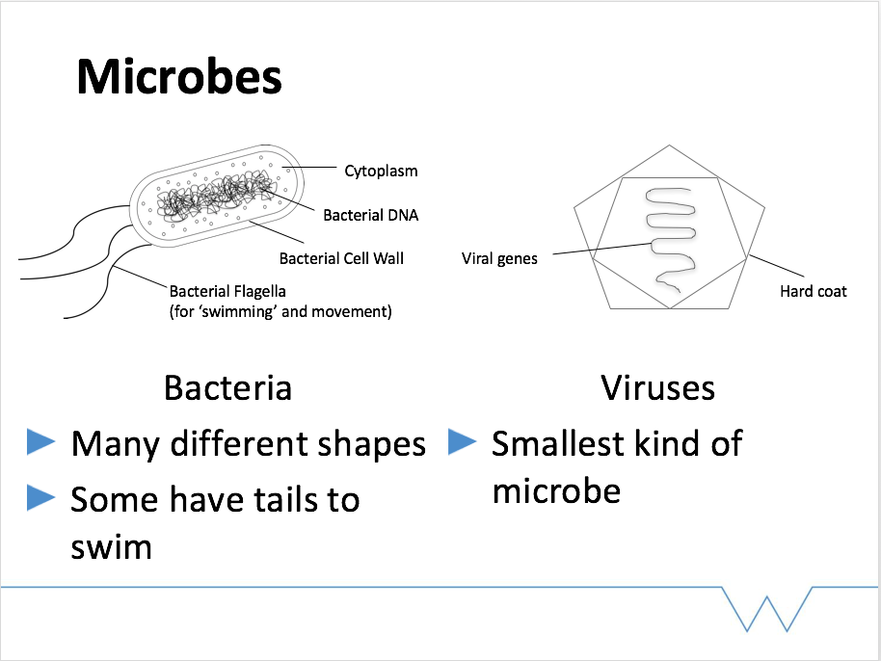 | - Adjust the level of what you say depending on what the responses were to the word game  - Emphasise the differences in structure, which leads on to the key message in the following slide;
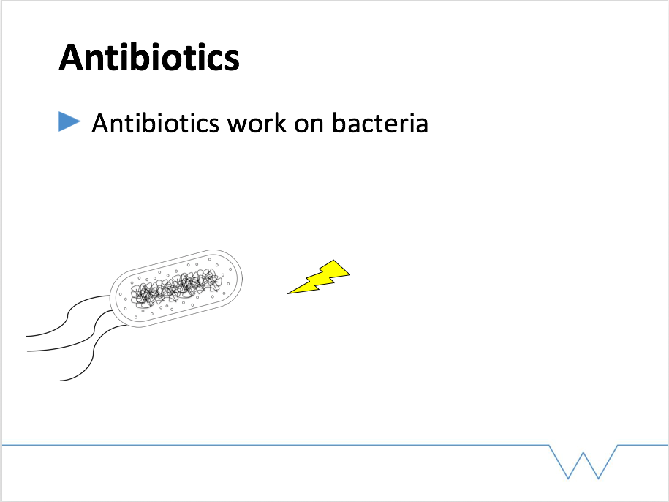 | - Antibiotics are drugs that kill bacteria – they don’t work on viruses because of the differences in viruses and bacteria
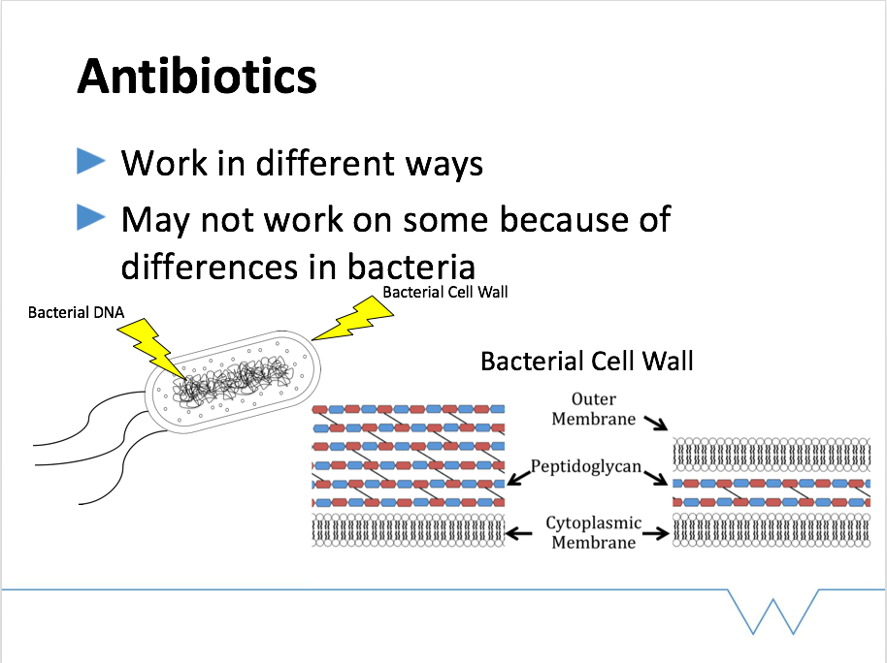 | - Explain that different antibiotics target different parts of bacterial cells – the cell wall is a major target  - The information on cell wall structure provides an introduction for the microscopy activity, which is based upon cell wall structure
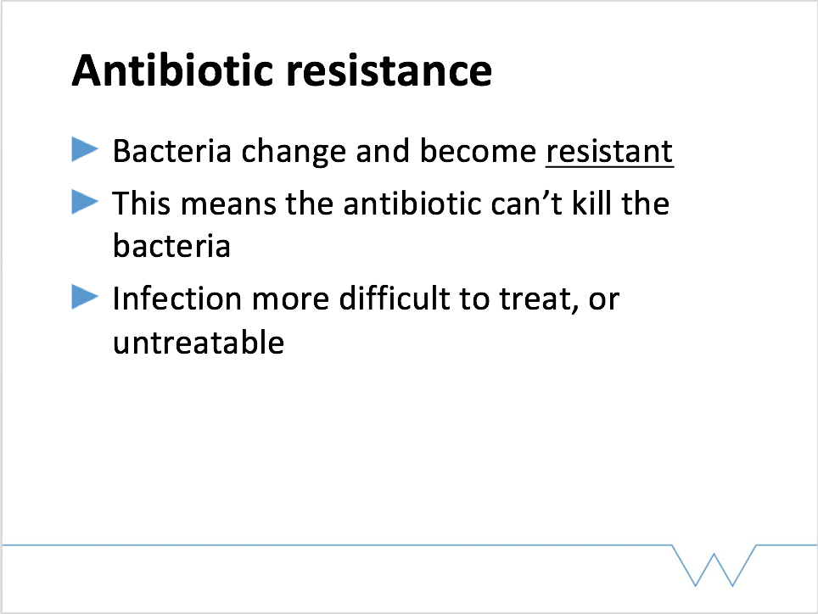 | - Link back to the discussion from the word game and what this term means.
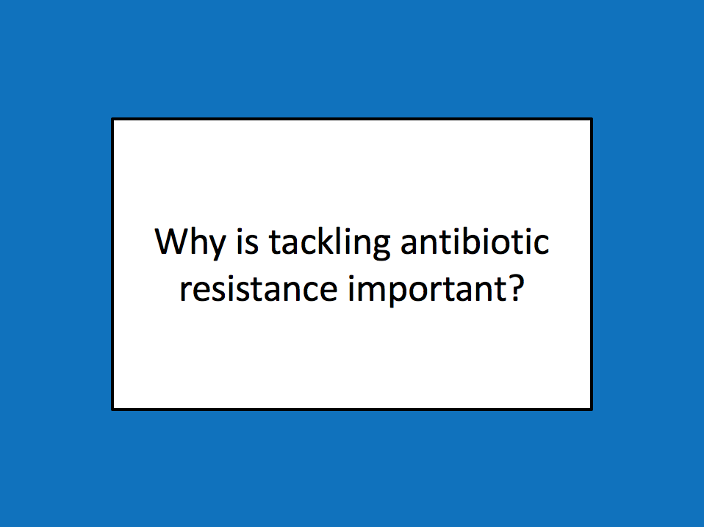 | - Ask the class why they think antibiotic resistance is an important problem.  - “Can anyone think of who this might affect?” Lead towards people in hospital, very young and very old  - If infections can’t be treated, people will die of diseases that are currently treatable (lead on to next slide)
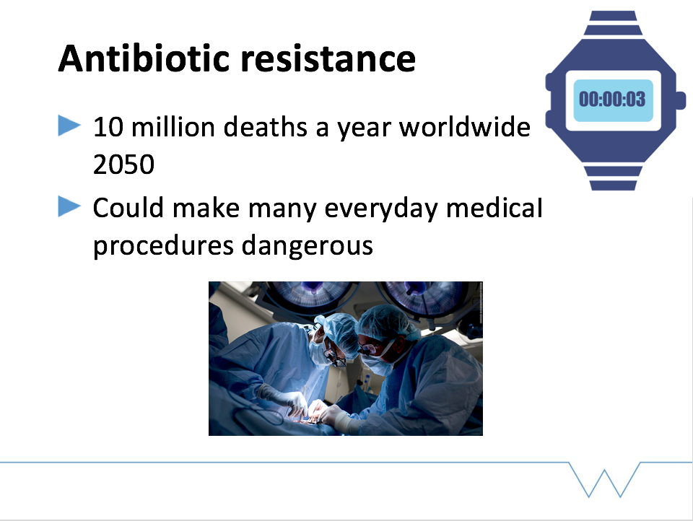 | - It has been estimated that by 2050, there will be 10 million deaths a year worldwide due to antibiotic resistance  - Give that in terms of time – one person every three seconds. I’ve been talking for about 5 minutes, so in that time 100 people would have died.  - In addition, a lot of medical procedures we may take for granted at the moment would become too dangerous if we couldn’t treat infections – ask the class if anyone has had surgery  - For this reason, people say that without action against antibiotic resistance, we could end up back in the ‘stone age’ of medicine
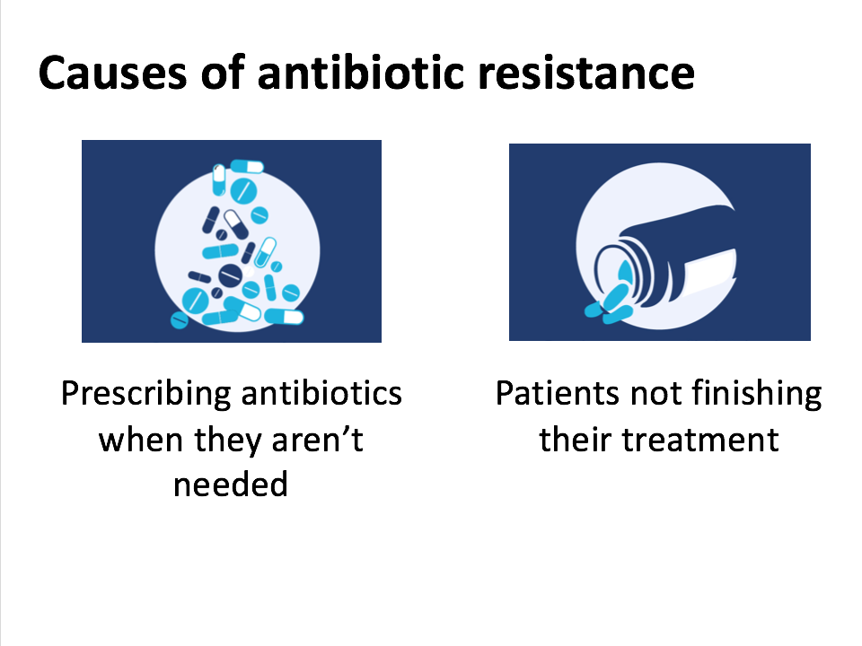 | - Bad prescribing – can anyone think of an infection that’s caused by viruses? Antibiotics won’t work for those (if it doesn’t come up, prompt cold and flu)  - The antibiotic tablets you’re given by your doctor are called a course – you need to take all of those because the full course should kill all of the bacteria. If you don’t finish the course, not all the bacteria die and some could become resistant
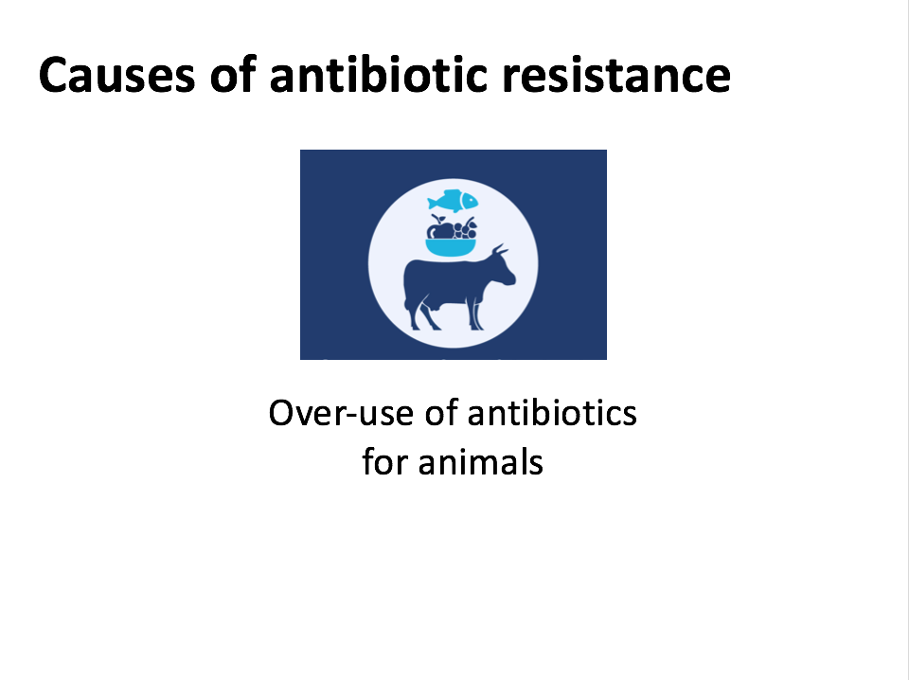 | - Antibiotics in farm animals and in the environment, create a selection pressure (relate to evolution) for resistant bacteria, which may then be transmitted to humans
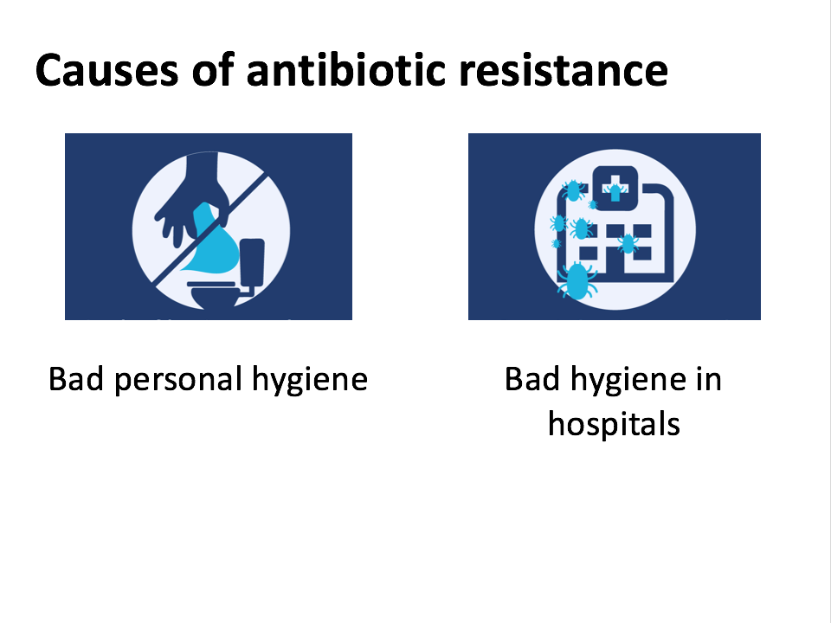 | - Bad personal hygiene (e.g. not washing your hands properly) makes it more likely that you and other people will get sick, and so more antibiotics have to be used. Also, antibiotic resistant bacteria can spread through bad hygiene.
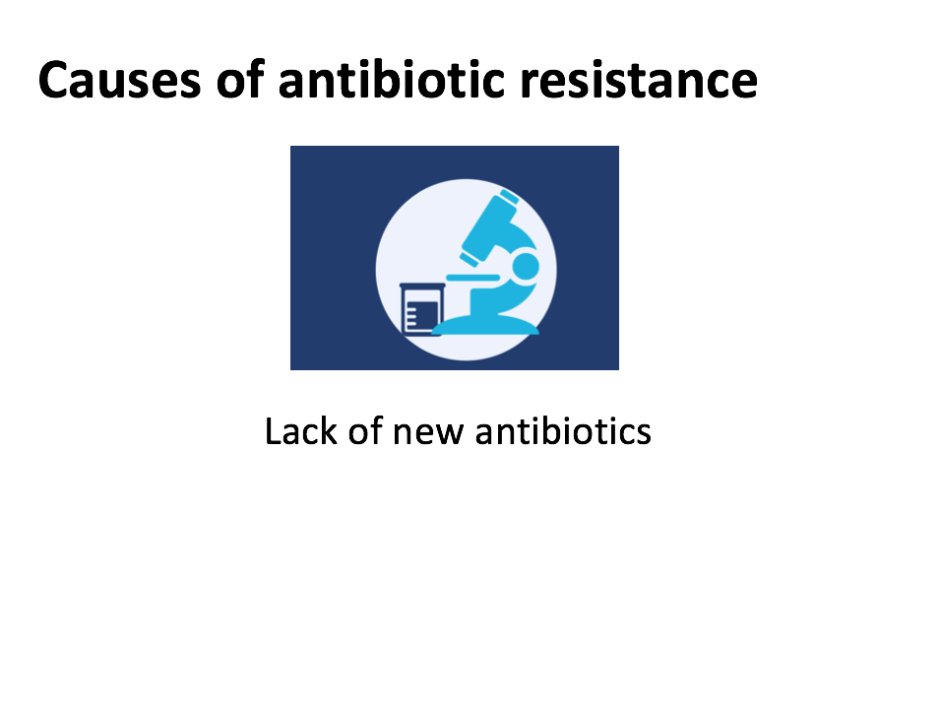 | - Another big problem is that it takes a long time and a lot of money to develop new antibiotics  - How long do the class think it can take to make a new drug and test that it’s safe and effective? (10 years)  - How much money do the class think this process can cost? (£1m)  - This makes it really important that we keep the antibiotics that we have working for as long as possible.
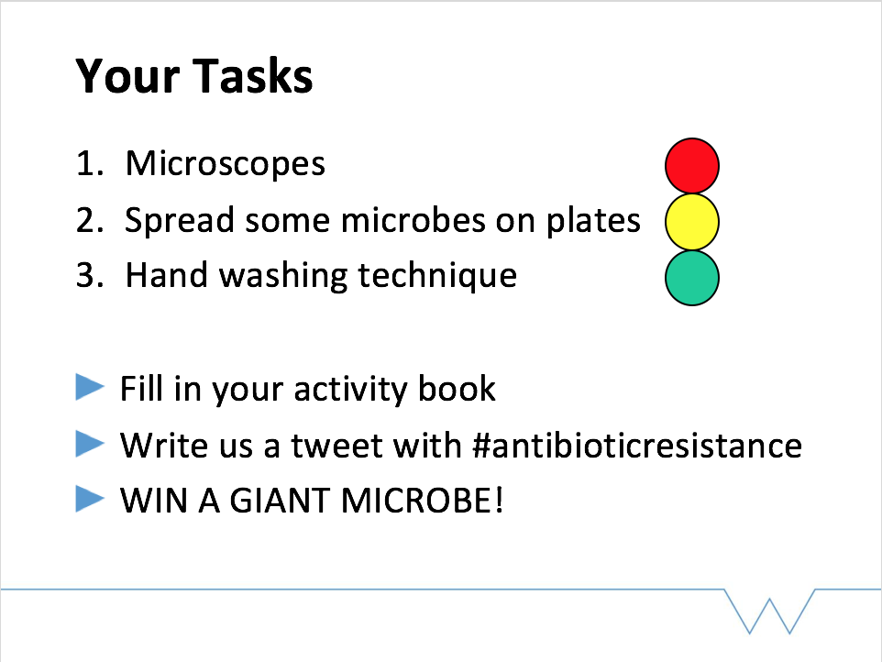 | - So now we want you to have a go at being microbiologists (that’s scientists who work on bacteria)  - (Indicate the stations as you introduce the activities) you’ll be looking at some bacteria using the high-tech microscopes; you’ll have a go at spreading some cultures; and we have some glowing paint for you to test how good your hand washing technique is! Whichever colour you have on your name sticker, tells you where you’ll be starting.  - You’ll also have activity books to fill in – everyone who completes theirs will be entered into a prize draw to win a Giant Microbe

Activities
During the workshop, students move between 3 stations, taking notes as they go in the lab book section of the booklet. In downtime at the stations or after completing each station, students can fill in their booklet.

- Microscopy – students are shown the difference between Gram-positive and Gram-negative bacteria (in terms of cell wall structure). They will then observe a number of different Gram stains, and note down the shape and colour (and therefore whether the bacteria are Gram-positive or Gram-negative). Volunteers can then check answers, and explain the ecology of the different bacteria presented – stickers or laminated cards should be placed by each microscope with this information.
- Single colony streaking – the demonstrator will first explain that this is a technique used by microbiologists to obtain many bacteria that are genetically identical and therefore useful to study. Students will streak out a liquid culture of bakers’ yeast, this will be incubated at 37°C for a few days until single colonies can be seen. The demonstrator will first follow the pattern on a laminated picture of a plate. This will then be demonstrated, and described step-by-step with yeast on an agar plate. Students may draw on the back of their plate to help guide them. The plates are incubated at 37°C at the university, and pictures uploaded online.
- Hand washing technique – volunteers will discuss why it is important to wash your hands well and explain that this paint mimics the spread of bacteria. Students will be split into small groups, one student will have GloGerm™ paint sprayed on their hand, and will shake hands with other students. Everyone then washes their hands, and the students then look at their hands using a UV torch, which will allow visualisation of any ‘bacteria’ they have missed during the hand washing procedure.

Questions
In their first task, students will be given some questions on paper – these should be discussed as a group. The slips can be kept following the workshops as a record of learning outcomes.

The questions are;
- What is antibiotic resistance?
- Can antibiotics cure cold or flu?
- You can stop taking antibiotics as soon as you feel better – True or False?
- How can we tackle antibiotic resistance?

Plenary Session
In the plenary session, the class will be asked for their answers to the questions. Where necessary these should then be discussed (i.e. why are these the right answers?). Take this time to clarify any on-going misconceptions.

Feedback
Pupil feedback is collected using coloured tokens and sweet jars. Students are asked to answer two questions:
- Which activity did you like best?
(Students place their token in the corresponding jar)
- Did we do a good job explaining what antibiotic resistance is?
(Students rate us using coloured tokens, with green for yes, yellow for sort of and red for no)
This feedback can be collected in downtime following the three tasks, or as students leave the laboratory.
In addition to this exercise, the teachers involved should be contacted for their written feedback following the workshops.
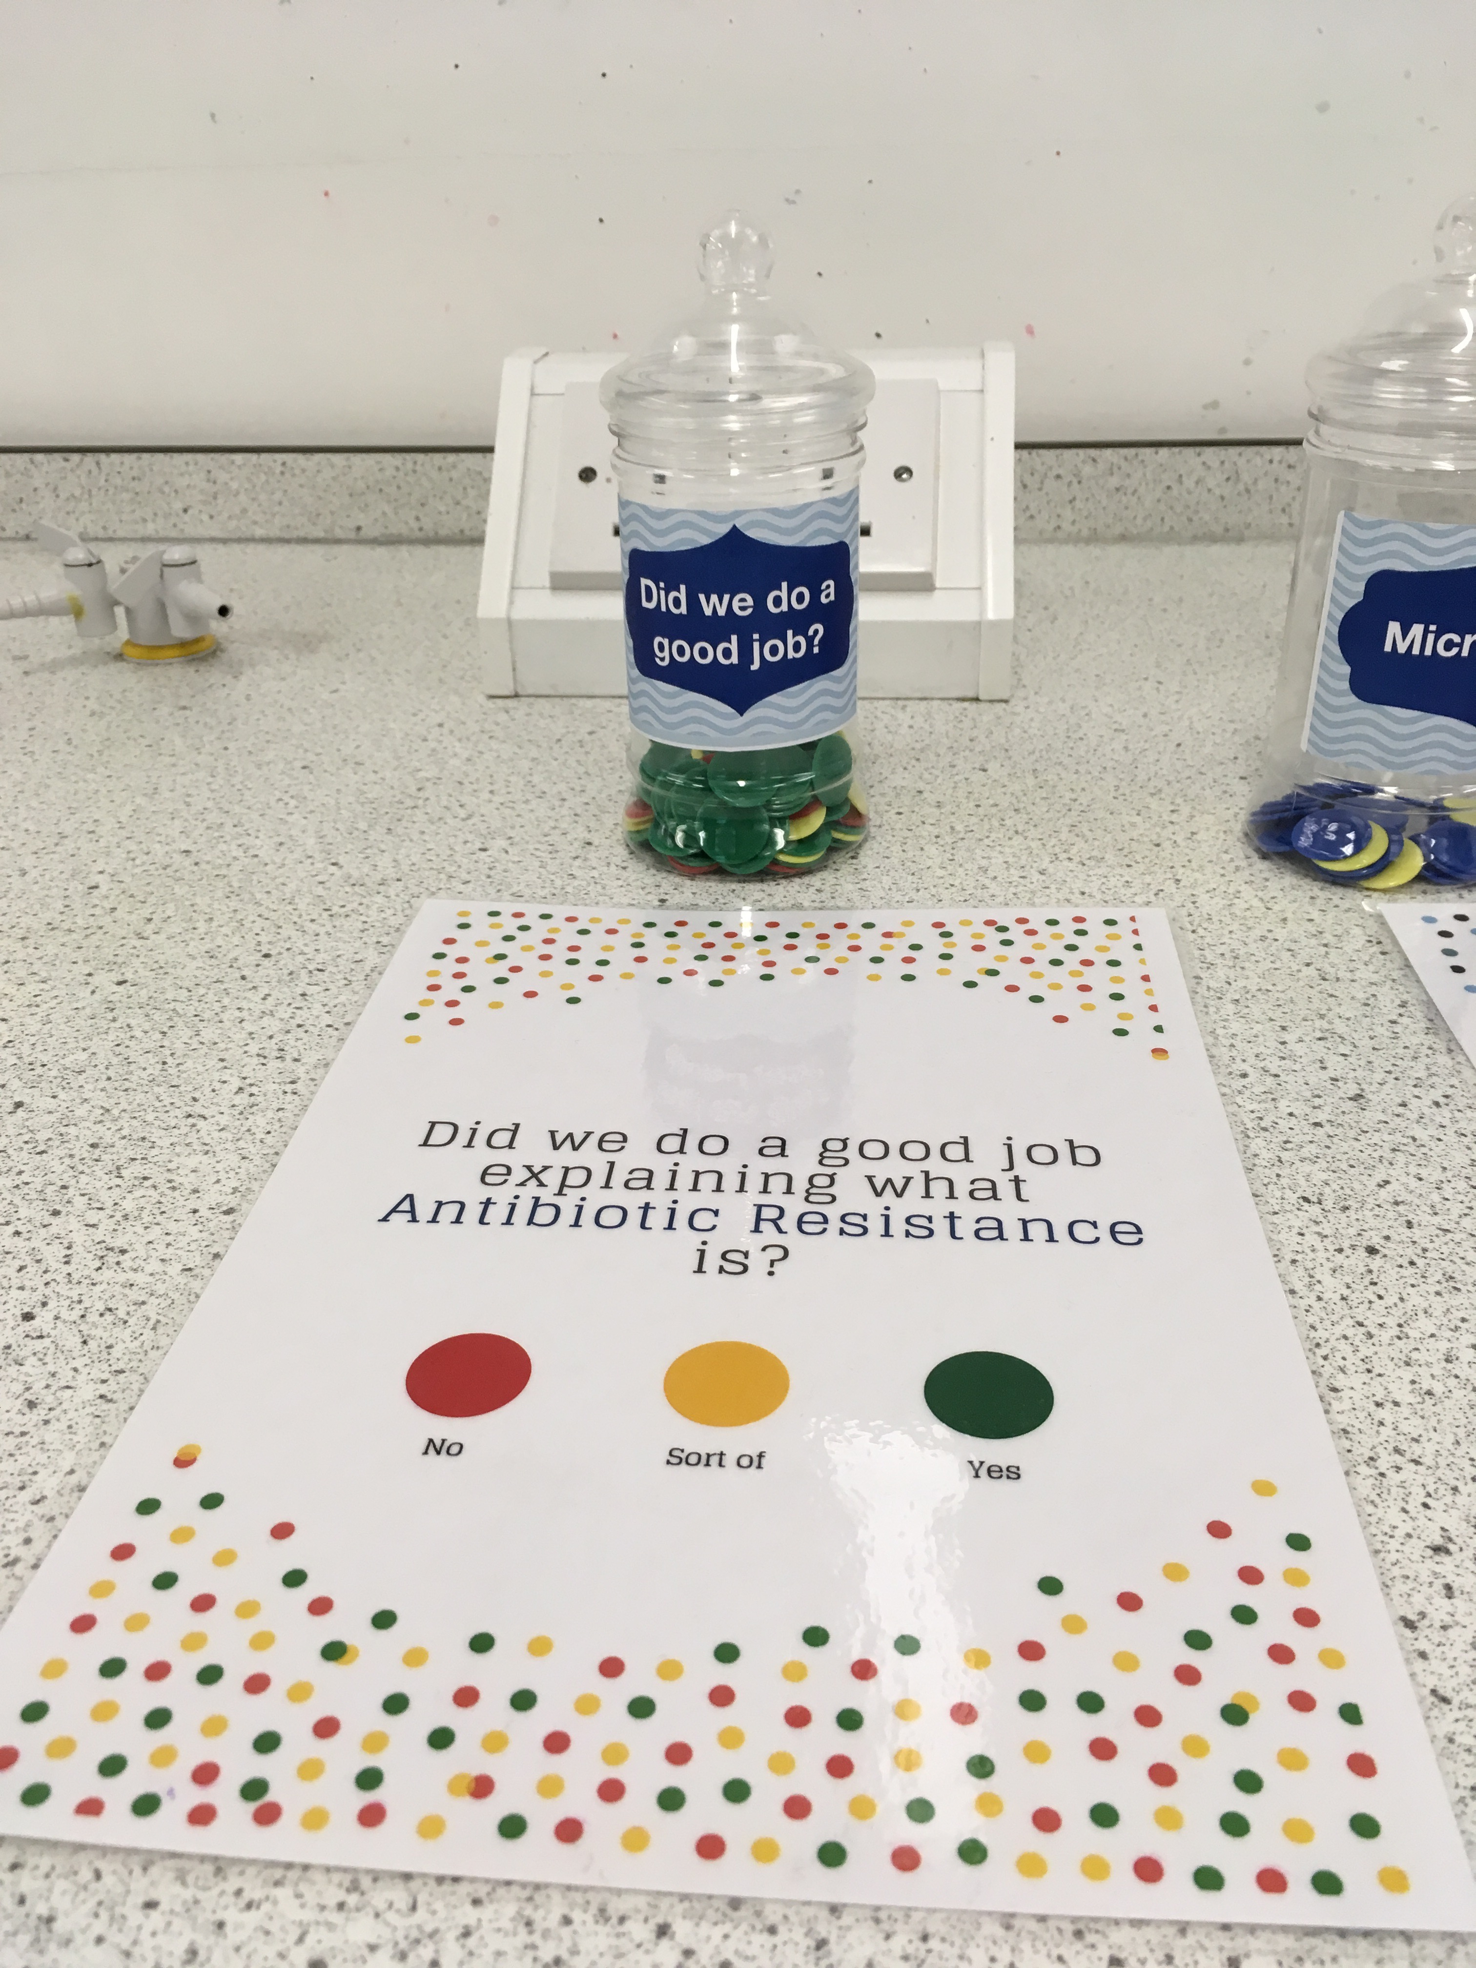
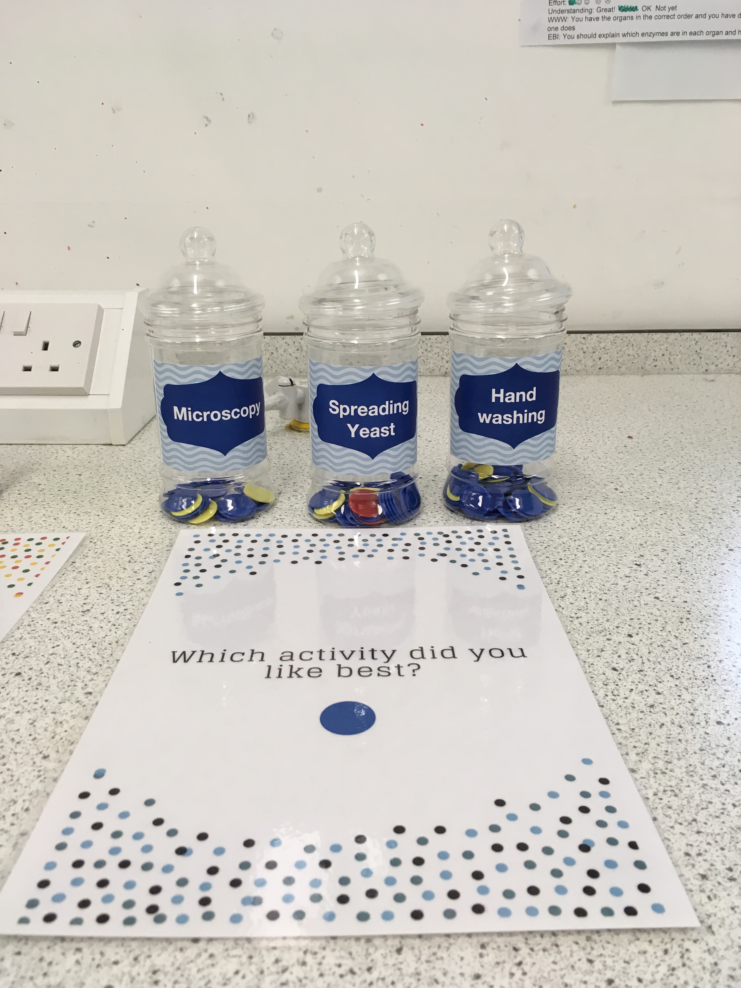
Figure 1: The feedback system. Jars and tokens are used for students to tell us their favourite activity and rate our explanation of antibiotic resistance.

Preparation Checklist for the Workshop
- Contact local schools and arrange date, number of classes
  - Check with the school (telephone with a follow up email)
    - Arrival time for volunteers (1.5hours before the first workshop) and logistics for workshop set up (parking, distance to classroom etc.)
    - Timing of the school day (start of lessons, break/lunch)
    - Facilities in the science classroom (handwashing activity requires a sink, microscopes will need power outlets, projector to give presentation)
    - Obtain names of students in each class and any pupils that should not be grouped together
- Allocate students to three groups and print name badges (taking into account any students who cannot be grouped together), compile name badges and feedback question sheets for each class
- Arrange order for printing of workbooks – allow one month to give time for obtaining a proof, and for contingency
- Advertise for volunteers and arrange training – consult local expertise (e.g. arrange for talks from members of your department with experience in outreach)
- Assemble materials (see table x) and test equipment with the volunteers prior to the workshop
- Organise transport for volunteers and equipment (include a contingency plan)

Materials
Table 4: The materials required for 'Antibiotic Awareness'
Type | Item | Notes
Digital | Presentation for volunteers (background on antibiotic resistance, structure of the workshops) | To deliver at training session
 | Antibiotic Awareness Introductory Talk presentation
 | Antibiotic Awareness workbook | 1.25 x no. of students. Allow one month for printing
 | Name stickers (with coloured stickers to allocate students to groups) | Ask teachers for list of first names for each class, print using label wizard
 | Laptop for presentation
 | Question slips | For plenary questions, 1 per group
Streaking | Sterile loops | 1.25 x no. of students
 | Agar plates | 1.25 x no. of students. Extra plates to account for mistakes and and to demonstration plates
 | Yeast liquid culture aliquots | 2-3 aliquots. Bakers’ yeast (Saccharomyces cerevisiae)
 | Tip jar | One per class. For disposal of loops
 | Nitrile gloves | 3 packs small, 2 medium and 1 large (scale to number of classes)
Microscopy | Microscope x5 | If available, use at least one microscope that can be connected to a screen, to allow visualisation of the slides to be demonstrated to larger groups
 | Immersion oil
 | Lens tissue
 | Gram stains | Allow for 2 stains per microscope, and choose the best stains before arriving for quicker setup on the day
 | Organism labels | Check which organisms you have Gram stains for, write and print label cards with the name and some information about each organism
 | Gram stain diagrams | For reference when students are viewing the slides
 | Sharps bin | For disposal of broken slides

Type | Item | Notes
Handwashing | GloGerm™ paint (with keyring UV lights)
 | Hand washing diagrams | Good diagrams can be found online
Feedback | Red, yellow, green and blue tokens | Bring excess so that votes can be counted later
 | Pots for voting | 4 pots, with labels corresponding to the feedback questions
 | Feedback question slips | 3 sets per class (one per colour group)

